41st District Agricultural Association/Del Norte County Fair
421 Hwy 101 North Crescent City, Ca. 95531
707-464-9556, 1-800-350-9556, Fax 707-464-9519
Website: www.dnfair.org
Email: info@dnfair.org

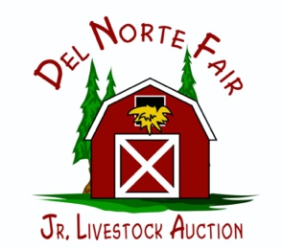

Junior Livestock Auction Agenda
Monday, January 20, 2025
5:00 pm

- Review Fair Recap notes from previous meeting
- Auction Financial Summary
- Set Date for Fair Book to be out, and set dates to work on it
- Set Steer weigh in dates
- Sponsorships for Awards
- Structure of Committee
- Review Bylaws
- Elections for JLA Committee
- Improvements or Upgrades for 2025 Fair
- Grants
- Other

AMERICAN WITH DISABILITIES ACT
Pursuant to the American with Disabilities Act, individuals who, because of a disability, need special assistance to attend or participate in any Board meetings or Committee meetings, or in connection with other District Fair activities, may request assistance at the 41st DAA Fair office, 421 Hwy 101 N., Crescent City Ca. or by calling 707-464-9556. Requests should be made one (1) week in advance whenever possible.

